Sprint - 4 Deliverables USN-7: Creating the Report and Story

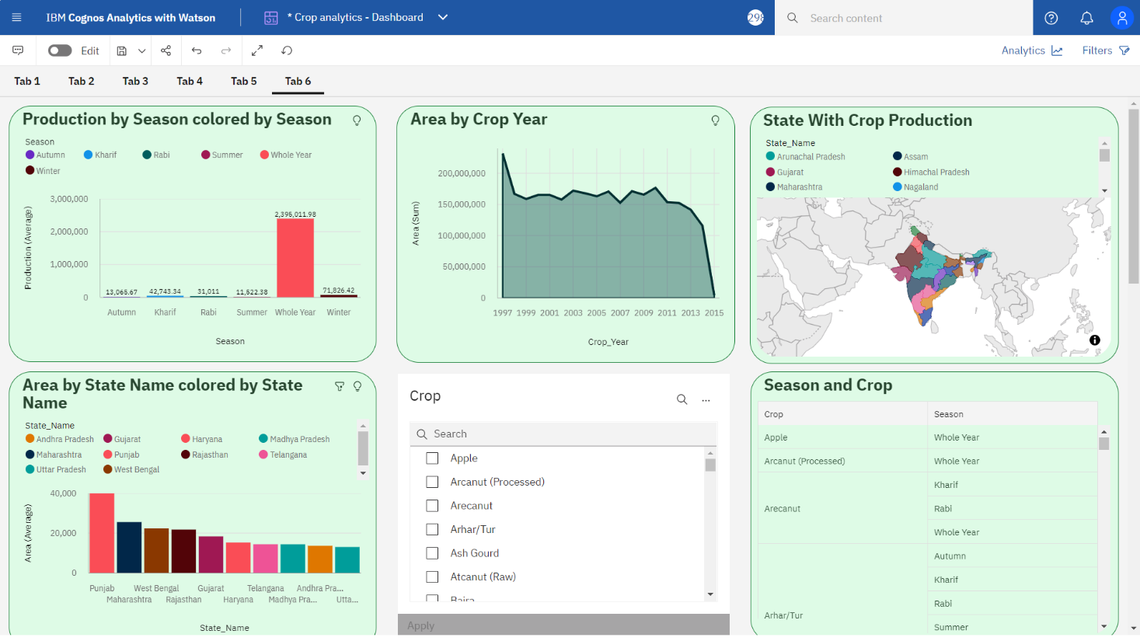

USN-8: Building Web App and embedding Dashboard, Report and Story

